**Handshake ‘Job Description’ Section Template**

**The complete guide for posting a position on Handshake can be found** [**on the Employee and Labor Relations website**](https://hr.uoregon.edu/student-worker-hiring-and-job-posting)**. Please use the complete guide whenever posting a job on Handshake.**

**This template should be inserted in the ‘Job Description’ section of Handshake.** The ‘job description’ section is the first section of the Handshake posting. This template can be copied directly into the ‘job description’ field in Handshake.

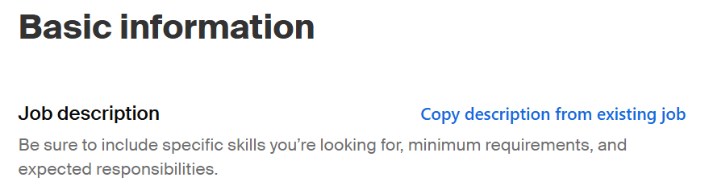

**Please note that this template was designed to ensure that the necessary information is included to comply with the UOSW Collective Bargaining Agreement (CBA).** Please be sure to complete all sections. If you make changes to the template, you must confirm it is still in compliance by consulting the Hiring and Job Postings article in the UOSW CBA.

It is necessary to have a complete [position description](https://hr.uoregon.edu/student-worker-position-descriptions) before posting a job on Handshake.

**---------------------------------------BEGINNING OF TEMPLATE ----------------------------------------**

[**DENOTE CLEARLY HERE IF POSITION IS WORK STUDY ONLY –** if not, delete this line]

**POSITION INFORMATION:**

Program Information

[COPY “PROGRAM INFORMATION” SECTION FROM POSITION DESCRIPTION]

Job Duties

[COPY “JOB DUTIES” SECTION FROM POSITION DESCRIPTION]

Minimum Qualifications

[COPY “MINIMUM QUALIFICATIONS” SECTION FROM POSITION DESCRIPTION]

Preferred Qualifications

[COPY “PREFERRED QUALIFICATIONS” SECTION FROM POSITION DESCRIPTION—If none, delete this section]

Scheduling Information

[INPUT SUMMARY OF SCHEDULING REQUIREMENTS—e.g. required hours/week, required shifts, hours of operation, etc.]

[CLEARLY DENOTE MANDATORY TRAININGS HERE]

Appointment Information

[INPUT SUMMARY OF APPOINTMENT INFORMATION—e.g. appointment end date, reappointment process, etc.]

[BACKGROUND CHECK REQUIRED?—If this position requires a background check, indicate that here. If not, delete this section]

**APPLICATION NOTES:**

For questions about this job posting, contact [INPUT NAME AND EMAIL].

*For full details on this position, please view the attached position description. Alternate formats of the position description are available upon request.*

* * * * * * * * * * * * * * *

The University of Oregon is an equal opportunity, affirmative action institution committed to cultural diversity and compliance with the ADA. The University encourages all qualified individuals to apply and does not discriminate on the basis of any protected status, including veteran and disability status. The University is committed to providing reasonable accommodations to applicants and employees with disabilities. To request an accommodation in connection with the application process, please contact us at [uocareers@uoregon.edu](mailto:uocareers@uoregon.edu) or 541-346-5112.

UO prohibits discrimination on the basis of race, color, religion, national origin, sex, sexual orientation, gender identity, gender expression, pregnancy (including pregnancy-related conditions), age, physical or mental disability, genetic information (including family medical history), ancestry, familial status, citizenship, service in the uniformed services (as defined in federal and state law), veteran status, expunged juvenile record, and/or the use of leave protected by state or federal law in all programs, activities and employment practices as required by Title IX, other applicable laws, and policies. Retaliation is prohibited by UO policy. Questions may be referred to the Office of Investigations and Civil Rights Compliance. Contact information, related policies, and complaint procedures are listed [here](https://investigations.uoregon.edu/reporting).

**-------------------------------------------END OF TEMPLATE -------------------------------------------**